-

Evaluating Students Satisfaction:
A Case Study

Christos Kilias
Informatics Department
TEI of Athens

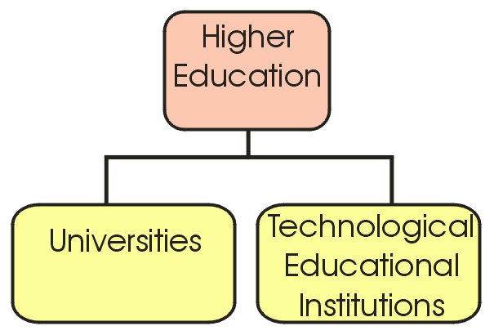

Fig. 1. Higher Education in Greece

1. Research methodology

2.1. Planning of the research

- Preliminary stage
- Development of the questionnaire
- Analysis
- Results

1.2. Definition of satisfaction criteria

1. Educational Program
2. Teaching Personnel
Educational Program + Teaching Personnel = Education
3. Tangibles
4. Administrative Support
5. Image of the Department
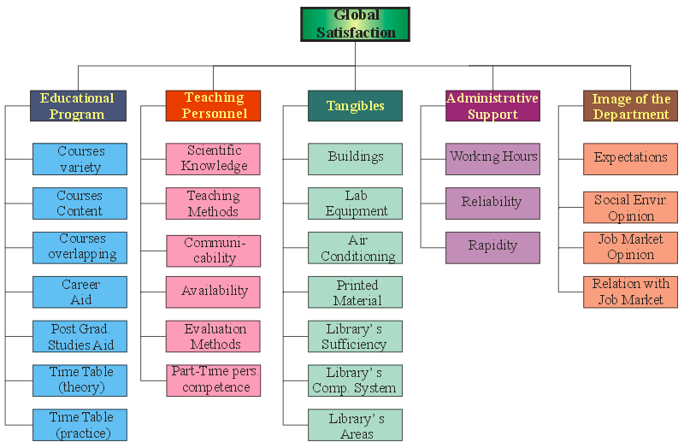

Fig.2. Hierarchical structure of students’ satisfaction criteria and sub-criteria
1.3. Development of the questionnaire

a) Fill in instructions
b) Personal data
c) Questions concerning satisfaction
- sub-criteria
  - 5-points Likert scale (ranged from “totally agree” to “totally disagree”)
- criteria and global satisfaction
  - 5-points Likert scale (ranged from “totally satisfied” to “totally dissatisfied”)
  - additional grade, ranged from 0 (worst) to 10 (excellent).
- criteria
  - an open question

4. | ΔΙΟΙΚΗΤΙΚΗ ΥΠΟΣΤΗΡΙΞΗ | Συμφωνώ απόλυτα | Κάπως συμφωνώ | Ούτε Συμφωνώ/ ούτε διαφωνώ | Κάπως διαφωνώ | Διαφωνώ πλήρως
 |  | ☺ |  | 😐 |  | ☹
4.1 | Το ωράριο λειτουργίας των διοικητικών υπηρεσιών του τμήματος (γραμματεία, ΚΔΕ κ.λπ.) είναι ικανοποιητικό
4.2 | Οι παρεχόμενες υπηρεσίες είναι αξιόπιστες
4.3 | Η εξυπηρέτηση είναι γρήγορη
 |  | Απόλυτα ικα- νοποιημένος | Κάπως ικα- νοποιημένος | Ούτε ικανοποιημένος/ ούτε δυσαρεστημένος | Λίγο δυσα- ρεστημένος | Πλήρως δυσα- ρεστημένος
 |  | ☺ |  | 😐 |  | ☹
4.4 | Συνολικά, πόσο ικανοποιημένος/η είσαι από τη Διοικητική Υποστήριξη του Τμήματος Πληροφορικής;
4.5 | Δώστε εδώ μια βαθμολογία συνολικά για τη Διοικητική Υποστήριξη του Τμήματος Πληροφορικής από 0 (χείριστη) μέχρι 10 (άριστη)

Fig. 3. A portion of the questionnaire

1.4. Conduction of the research

February 2004

950 questionnaires
Estimated over 95% of active students

1.5. Preliminary processes

- Data entry
- Data validation
- Search for missing values
- Track down inconsistent answers
2. Results of satisfaction measurement (based on qualitative data)

The MUSA (Multicreteria Satisfaction Analysis) method
- Aggregation of individual judgements into a collective value function
- Global satisfaction = sum of partial satisfactions
- Problem of qualitative regression
- Solved via linear programming formulations
2.1 Global and partial (per criterion) satisfaction

Fig. 4. Bar chart of global satisfaction relative frequencies

Table 1. Relative frequencies of global and per criterion satisfaction

 |  | Tottaly unsatisf. | Moder. unsatisf. | Neither satisfied /unsatisf. | Moder. satisfied | Perfectly satisfied
0 | GLOBAL SATISFACTION | 2% | 10% | 25% | 55% | 8%
1 | Educational Program | 4% | 16% | 33% | 43% | 4%
2 | Teaching Personnel | 5% | 22% | 34% | 35% | 4%
3 | Tangibles | 7% | 26% | 33% | 31% | 3%
4 | Administrative Support | 12% | 23% | 31% | 29% | 6%
5 | Image of the Department | 1% | 4% | 20% | 55% | 20%

Global average satisfaction index

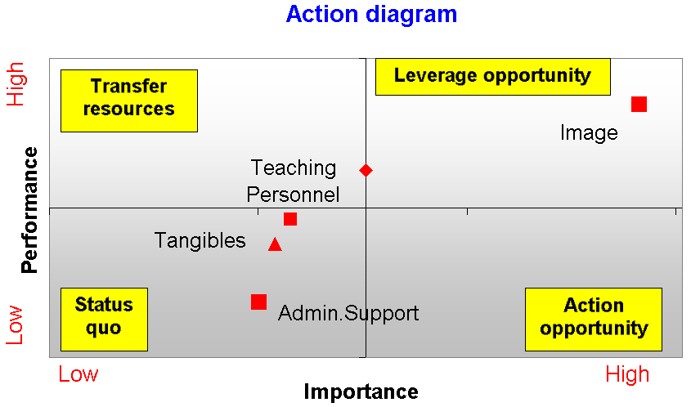
Educational Program

Low
High
High
Low
1st priority
Last priority

2.2 Satisfaction per criterion and sub-criteria

2.2.1 Educational Program

Table 2. Results of the Educational Program sub-criteria
Sub-criterion | Weight | Satisfa-  ction | Dema-nding | Impact
Y11. Courses variety | 0.19 | 0.84 | -0.48 | 0.03
Y12. Courses content | 0.14 | 0.54 | -0.01 | 0.06
Y13. Courses overlapping | 0.13 | 0.60 | -0.18 | 0.05
Y14. Carrier aid | 0.14 | 0.74 | -0.30 | 0.04
Y15. Post Grad. Studies aid | 0.14 | 0.70 | -0.30 | 0.04
Y16. Time table (theory) | 0.13 | 0.35 | 0.24 | 0.08
Y17. Time table (practice) | 0.13 | 0.38 | 0.20 | 0.08

Educational Program
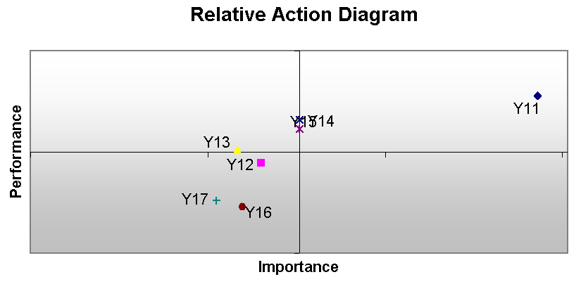
Time Table

2.2.2. Teaching Personnel

Table 3. Results of the Teaching Personnel sub-criteria

Sub-criterion | Weight | Satisfa-ction | Dema-nding | Impact
Y21. Scientific Knowledge | 0.18 | 0.81 | -0.45 | 0.04
Y22. Teaching Methods | 0.18 | 0.26 | 0.42 | 0.13
Y23. Communicability | 0.23 | 0.27 | 0.50 | 0.17
Y24. Availability | 0.14 | 0.45 | 0.17 | 0.08
Y25. Evaluation Methods | 0.13 | 0.39 | 0.24 | 0.08
Y26. Part-time personnel competence | 0.14 | 0.65 | -0.22 | 0.05

Teaching Personnel
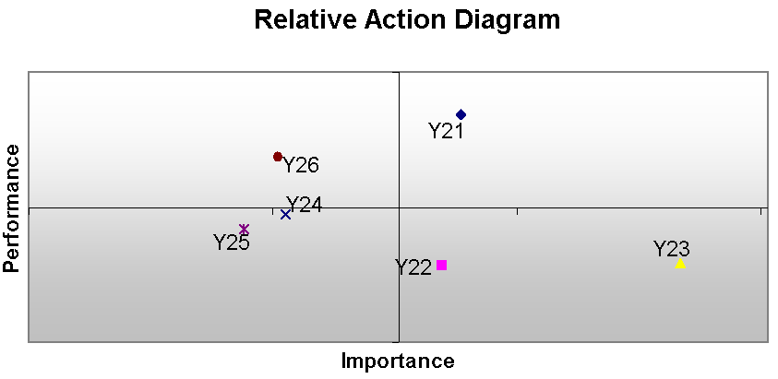
Communicability
Teaching Methods
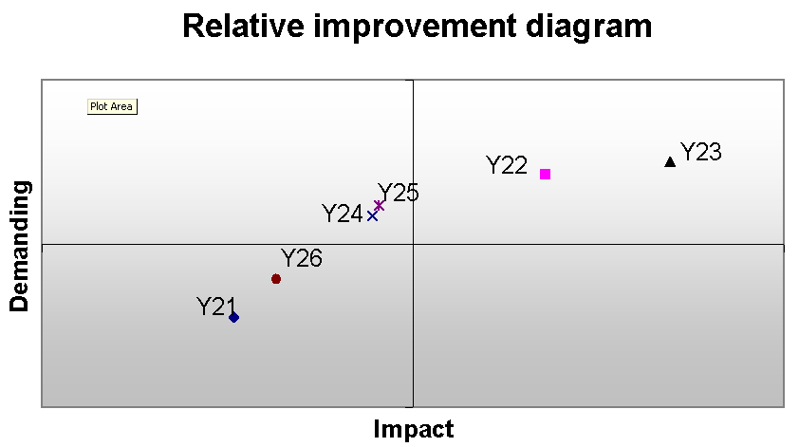

2.2.3 Tangibles

Table 4. Results of the Tangibles sub-criteria
Sub-criterion | Weight | Satisfa-  ction | Dema-nding | Impact
Y31. Buildings | 0.14 | 0.35 | 0.27 | 0.09
Y32. Lab Equipment | 0.16 | 0.25 | 0.39 | 0.12
Y33. Air conditioning | 0.14 | 0.28 | 0.29 | 0.10
Y34. Printed Material | 0.14 | 0.33 | 0.28 | 0.10
Y35. Library's sufficiency | 0.14 | 0.78 | -0.28 | 0.03
Y36. Library's comp. system | 0.14 | 0.71 | -0.28 | 0.04
Y37. Library's areas | 0,13 | 0,72 | -0,23 | 0,04

Tangibles

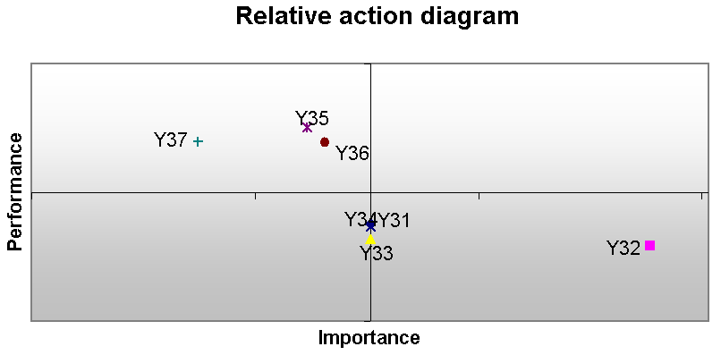
Lab Equipments
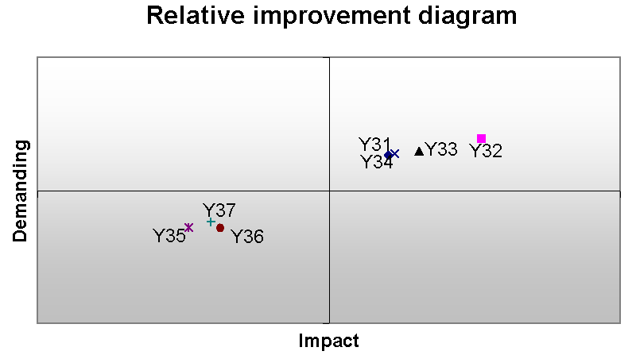

2.2.4 Administrative Support

Table 5. Results of the Administrative Support sub-criteria

Sub-criterion | Weight | Satisfaction | Demanding | Impact
Y41. Working hours | 0.34 | 0.16 | 0.70 | 0.28
Y42. Reliability | 0.20 | 0.74 | -0.50 | 0.05
Y43. Rapidity | 0.46 | 0.18 | 0.74 | 0.38

Administrative Support
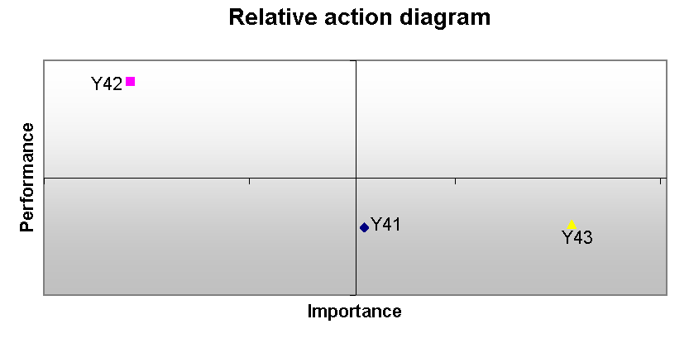
Rapidity
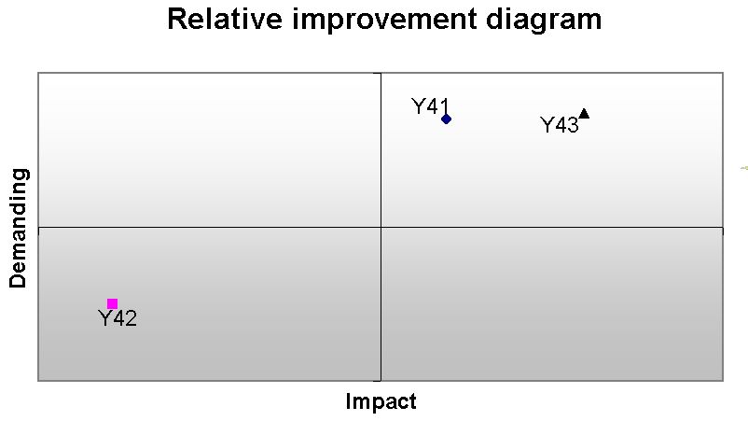

2.2.5 Image of the Department

Table 6. Results of the Image of the Department sub-criteria

Sub-criterion | Weight | Satisfa-ction | Dema-nding | Impact
Y51. Expectations | 0.14 | 0.74 | -0.29 | 0.04
Y52. Social Environment Opinion | 0.47 | 0.94 | -0.79 | 0.03
Y53. Job Market Opinion | 0.25 | 0.90 | -0.60 | 0.02
Y54. Relations with Job Market | 0.14 | 0.72 | -0.26 | 0.04

Image of the Department
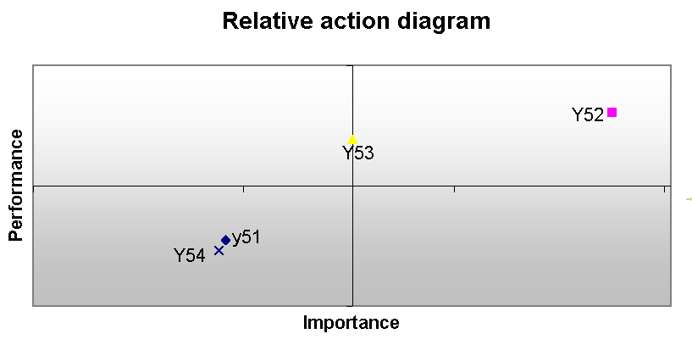
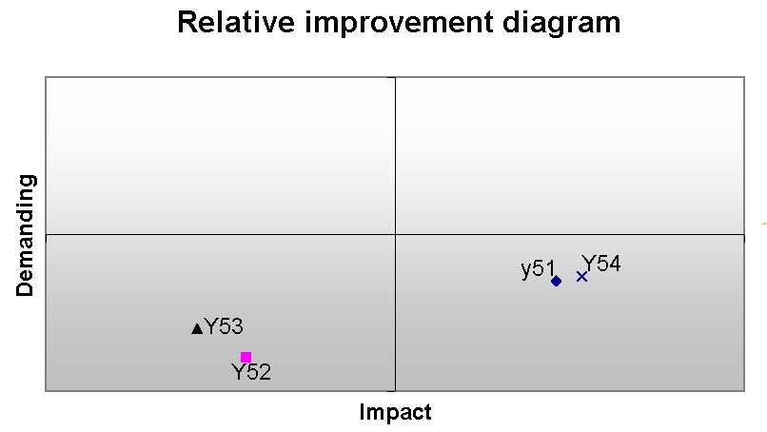
Expectationsns
Relations with Job Market

4. Results of the measurement of satisfaction (based on numerical data)

Table 7. Relative frequencies of global and partial (per criterion) satisfaction marks
 | 0 | 1 | 2 | 3 | 4 | 5 | 6 | 7 | 8 | 9 | 10
1. Educational Program | 1% | 0% | 1% | 3% | 5% | 19% | 24% | 27% | 16% | 4% | 1%
2. Teaching Personnel | 1% | 1% | 2% | 6% | 8% | 21% | 22% | 22% | 12% | 4% | 1%
3. Tangibles | 1% | 1% | 2% | 6% | 12% | 21% | 23% | 20% | 11% | 3% | 1%
4. Administr. Support | 3% | 2% | 3% | 8% | 11% | 22% | 16% | 16% | 11% | 5% | 3%
5. Image of the Department | 0% | 0% | 0% | 1% | 1% | 11% | 13% | 23% | 26% | 19% | 6%
0. Global satisfaction | 1% | 0% | 1% | 1% | 4% | 14% | 17% | 29% | 22% | 7% | 2%
Fig. 6. Histogram of global satisfaction frequencies

Table 8. Statistics of global satisfaction and partial satisfaction criteria

 | 1. Educa-tional Program | 2. Teach. Personnel | 3. Tangli-bles | 4. Admin. Support. | 5. Image | 0. Global satisfaction
Mean | 6.25 | 5.92 | 5.68 | 5.52 | 7.34 | 6.67
Standard Error | 0.05 | 0.06 | 0.06 | 0.07 | 0.05 | 0.05
Median | 6 | 6 | 6 | 6 | 7.5 | 7
Mode | 7 | 6 | 6 | 5 | 8 | 7
Standard Deviation | 1.55 | 1.73 | 1.78 | 2.22 | 1.59 | 1.62
Sample Variance | 2.40 | 2.98 | 3.18 | 4.95 | 2.53 | 2.63
Kurtosis | 1.42 | 0.46 | 0.52 | 0.02 | 1.37 | 1.79
Skewness | -0.71 | -0.45 | -0.49 | -0.40 | -0.78 | -0.86
Range | 10 | 10 | 10 | 10 | 10 | 10
Minimum | 0 | 0 | 0 | 0 | 0 | 0
Maximum | 10 | 10 | 10 | 10 | 10 | 10
Sum | 5888 | 5579 | 5347 | 5204 | 6912 | 6283
Count | 942 | 942 | 942 | 942 | 942 | 942
Confidence Level(95.0%) | 0.10 | 0.11 | 0.11 | 0.14 | 0.10 | 0.10

Table 9. Frequencies of the numeric grades corresponding to global satisfaction per step of the qualitative scale
Grade | Unsatisfied | Moderately Unsatisfied | Neither Satisfied/ Nor Unsatisfied. | Moderately Satisfied | Perfectly Satisfied | Total
0 | 6 |  |  |  |  | 6
1 | 2 | 1 |  | 1 |  | 4
2 | 8 | 1 |  |  |  | 9
3 |  | 11 | 1 | 1 |  | 13
4 | 3 | 27 | 6 | 1 |  | 37
4.5 |  | 1 | 1 |  |  | 2
5 | 1 | 37 | 75 | 20 |  | 133
5.5 |  |  | 4 |  |  | 4
6 | 2 | 16 | 71 | 66 | 3 | 158
6.5 |  |  | 2 | 6 |  | 8
7 |  | 4 | 66 | 196 | 2 | 268
7.5 |  |  | 1 | 7 |  | 8
8 |  |  | 4 | 180 | 18 | 202
8.5 |  |  |  | 5 | 1 | 6
9 |  |  |  | 32 | 32 | 64
9.5 |  |  |  |  | 1 | 1
10 |  |  |  | 3 | 16 | 19
Total | 22 | 98 | 231 | 518 | 73 | 942
Aver | 2.14 | 4.67 | 5.93 | 7.27 | 8.79

Test | Kendall rank correlation
Alternative hypothesis | 0.1  ≠  0.2
n | 942
tau statistic | -0,58
2-tailed p | <0.0001 | (normal approximation, corrected for ties)

Fig. 6. Kendall rank correlation test

Table 10. Weights of criteria computed with three methods
Criterion \ Method | L.P. | Regr. | MUSA
1. Educational Program | 0.33 | 0.38 | 0.20
2. Teaching Personnel | 0.11 | 0.13 | 0.14
3. Tangibles | 0.09 | 0.14 | 0.13
4. Administrative Support | 0.04 | 0.04 | 0.12
5. Image of the Department | 0.43 | 0.34 | 0.41

Fig. 7. Graphical representation of criteria weights per method

4. Some other results

4.1. Studies and work

- 41% of the students declare that they work.
- 59% of them work full time
- 52% work in the field of their specialty.

4.2 Post graduate studies

- 56% of the students have the ambition to continue with post graduate studies
- 8% will not continue their studies
- 36% are still uncertain.

4.3 Test of global satisfaction dependence

- Global satisfaction depends upon the semester (and the age).
- Global satisfaction is independent of students’ sex and employment.

Global satisfaction decrease at the beginning and increased in the end.

5. Conclusions – Proposals

- Global satisfaction 6.67
- Highest satisfaction (7.34): Image
- Lowest satisfaction (5.52): Administrative
Support

- Most important criterion: Image
- Less Important: Administrative Support
(12%) and Tangibles (13%)

- Demanding index very low value, except of
the Administrative Support criterion

- Improvement activities:

    - Tangibles
    - Administrative Support

- Sub-criteria level improvement efforts:

    - time table
    - instructive methods
    - laboratories’ equipment
    - air-conditioning
    - secretariat services’ rapidity
    - Relation to other educational institution and the job market

